HURTWOOD HOUSE

Complaints Policy
Reviewed | by | Last reviewed | Last modified
Annually | SMT | May 2024 | May 2023

- Introduction
  - Circulation: this policy is addressed to the Senior Management Team; to all members of the teaching and pastoral staff, including school medical staff and nursing staff; and, on request, to parents. A copy can be downloaded from the School's website and it is included in the Student and Parent Handbook.
  - Policy status: the policy has been approved by the Headmaster and the Partners of Hurtwood House (School). It provides guidelines for handling complaints and it takes account of Part 7 of the Education (Independent School Standards) (England) Regulations 2014 and the National Minimum Standards for Boarding Schools. The policy applies to all sections of the school. The procedures set out below may be adapted as appropriate to meet the policy aims and circumstances of each case. Certain of the procedures can only be carried out during term time.
  - Application: separate procedures apply in the event of a child protection issue or if the Headmaster expels or asks a student to leave and the parents seek a review of that decision.
  - Parent/s / You: includes a current or prospective parent or legal guardian or education guardian, and may at our discretion include a parent whose child has recently left the School. Complaints directly from students are dealt with under a separate procedure, a copy of which is published in the Student Parent Handbook.
  - Definition of complaint: any matter about which a parent of a student is unhappy and seeks action by the school.
  - Three stages: this policy describes a three stage complaints procedure:
- Stage 1: informal raising of a complaint notified orally or in writing to a member of staff
- Stage 2: a formal complaint in writing to the Headmaster
- Stage 3: a reference to the Complaints Panel
Timescales : We aim to resolve any complaints in a timely manner. Timescales for each stage are set out below in the relevant paragraphs. When we refer to "working days" we mean Monday to Friday, when school is open during term time. The dates of terms are published in the Student and Parent Handbook.
  - A concern about the safety of your son/daughter should be notified immediately to the person you believe is best placed to take urgent action and should be confirmed in writing to the Headmaster.
- Policy aim and statement
  - Aim: the aim of this policy is to ensure that a complaint is managed sympathetically, efficiently and at the appropriate level, and resolved as soon as possible. Doing so is good practice, it is fair to those concerned and it helps to promote parents' and students' confidence in our ability to safeguard and promote welfare. We will try to resolve every complaint in a positive way with the aim of putting right a matter which may have gone wrong and, where necessary, reviewing our systems and procedures in light of the circumstances.
  - Policy statement: we need to know as soon as possible if there is any cause for dissatisfaction. We recognise that a difficulty which is not resolved quickly and fairly can soon become a cause of resentment, which would be damaging to relationships and also to our school culture. Parents and students should never feel - or be made to feel - that a complaint will be taken amiss or will adversely affect a student or his/her opportunities at this school.
- Management of complaints
  - Complaints Co-ordinator: the Headmaster has appointed the Deputy Head - Personnel (DHP) as the Complaints Co-ordinator to be responsible for the co-ordination and administration of the Complaints Procedure. If the Complaints Co-ordinator is unavailable or is the subject of the complaint, his duties will be carried out by the Headmaster or another senior member of staff. The main responsibilities of the Complaints Co-ordinator are to:
- be the first point of contact while the matter remains unresolved and keep records;
- co-ordinate the complaints procedures in school;
- ensure that all School employees are aware and familiar with this procedure and arrange training where appropriate;
- monitor the keeping, confidentiality and storage of records in relation to complaints;
- report regularly to the Headmaster with respect to complaints.
  - Complaints Log: every Stage 2 complaint notified to a member of staff will be noted, together with the action taken, in the School’s Complaints Log.
- Stage 1: Informal complaint
  - Informal complaint: we expect that most complaints, where a parent or student seeks intervention, reconsideration or some other action to be taken, can be resolved informally. Examples might include a dissatisfaction about some aspect of teaching or pastoral care, or about allocation of privileges or responsibilities, or about a timetable clash or some other aspect of the School's systems or equipment, or a billing error.
  - Notification: please raise the complaint initially as follows:
    - educational issues - if the matter relates to the classroom, the curriculum or special educational needs, please speak or write to the student's Housemaster/Housemistress or the Deputy Head - Students, as appropriate;
    - pastoral care and welfare of students - for complaints relating to matters outside the classroom or in the House, please speak or write to the student's Housemaster/ Housemistress, the Deputy Head - Students or the school’s Senior Management Team (SMT);
    - disciplinary matters - a problem over any disciplinary action taken or a sanction imposed should be raised first of all with the student's Housemaster/Housemistress or the Deputy Head - Students;
    - financial matters - a query relating to fees or extras should be stated in writing to the Finance Manager.
  - Acknowledgement: we will acknowledge a written notification by telephone, e-mail or letter within three working days of receipt during term time and as soon as practicable in the holidays. A matter raised orally will not necessarily be acknowledged in writing but parental contact will be noted on a Student Record form which will be filed.
  - Unresolved informal complaints: a complaint which has not been resolved by informal means within 15 working days should be notified in writing as a formal complaint which will be dealt with in accordance with Stage 2 below.
- Stage 2: formal complaint
  - Notification: an unresolved complaint under Stage 1, or a complaint which needs investigation, or dissatisfaction with some aspect of the School's policies, procedures, management or administration should be set out in writing with full details and sent with all relevant documents and your full contact details in an envelope addressed to the Headmaster or to the Complaints Co-ordinator. Your complaint will be acknowledged by telephone or in writing within three working days during term time, indicating the action that is being taken and the likely time scale.
  - Investigation: the Headmaster may ask a senior member of staff to act as "investigator". The investigator/s may request additional information from you and will probably wish to speak to you personally and to others who have knowledge of the circumstances. The outcome of the investigation will be reported to the Headmaster who will then notify you in writing of his decision and the reasons for it. Written records will be kept of all meetings and interviews held in relation to your complaint.
  - Outcome: The Headmaster's aim would be to inform any complainant of the outcome of an investigation and the resolution to the complaint within 28 working days from the receipt of the complaint. Please note that any complaint received within one month of the end of term or half term is likely to take longer to resolve owing to the presence of school holidays and the unavailability of personnel.
- Stage 3: reference to the Complaints Panel
  - If you are dissatisfied with the response under Stage 2, the matter can be referred to the Complaints Panel. A Panel hearing is a review of the decisions taken by the Headmaster. The Panel will not consider any new areas of complaint which have not been previously raised as part of the complaints procedure. If parents seek to invoke Stage 3 they will be referred to Ms Susan Teal, a person independent of the running and management of the School, who has been appointed by the Partners and the Senior Management Team to call hearings of the Complaints Panel.
  - The role of the Panel: the Panel's task is to establish the facts surrounding the complaints that have been made by considering:
- the documents provided by both parties; and
- any representations made by you or the Headmaster.
  - If, after establishing the facts, the Panel consider that the complaint is made out, they will uphold the complaint. If the Panel consider that the complaint is not made out, they will dismiss the complaint. They will make these decisions on the balance of probabilities.
  - It is not within the powers of the Panel to make any financial award, nor to impose sanctions on staff, students, or parents. The Panel may make recommendations on these or any other issues to the Headmaster or to the Partners as appropriate.
  - Composition: Ms Teal will appoint the Panel, which will include herself, who is independent of the governance, management, and running of the School and at least two other members.
  - Notification: to request a hearing before the Complaints Panel please write to Ms Teal (with a copy to the Complaints Co-ordinator) at Holmbury St Mary, Dorking, Surrey RH5 6NU, within five working days of the decision you wish to be reviewed. Your request will only be considered if you have completed the procedures at Stages 1 and 2. Please ensure that a copy of all relevant documents and your full contact details accompany your letter to Ms Teal. Please state in your letter the outcome that you desire and all the grounds of your complaint. Please also send Ms Teal a list of the documents which you believe to be in the School's possession and wish the Panel to see. Ms Teal will aim to acknowledge your request in writing within five working days.
  - Convening the Panel: Ms Teal will convene the Complaints Panel as soon as reasonably practicable but the Panel will not normally sit during school holidays. The Panel will consist normally of a minimum of three individuals who have no detailed prior knowledge of the circumstances of the complaint. One member of the Panel will be an independent member. You may ask Ms Teal to tell you who has been appointed to sit on the Panel.
  - Notice of hearing: Every effort will be made to enable the Panel hearing to take place as soon as possible, and in any event, within 15 working days of the receipt of your request. As soon as reasonably practical and in any event, at least five working days before the hearing, Ms Teal will send you written notification of the date, time and place of the hearing, together with brief details of the Panel members who will be present. The hearing will normally be in a prescribed format, which is available on request from the Complaints Co-ordinator.
  - Attendance: you will be asked to attend the hearing and may be accompanied by one other person such as a relative, teacher, or friend. It is not necessary for that person to be legally qualified but if you do wish to be accompanied by a legally qualified person, acting in their professional capacity, please notify the School at least seven working days before the hearing. Your son/daughter may attend part or all of the hearing at the discretion of Ms Teal. Copies of additional documents you wish the Panel to consider should be sent to Ms Teal at least three clear working days prior to the hearing.
  - Chair: the hearing will usually be chaired by Ms Teal and will be conducted in an informal manner.
  - Hearing: all statements made at the hearing will be unsworn. All present will be entitled, should they wish, to write their own notes for reference purposes. A member of the School's administrative staff will be asked to take handwritten minutes of the proceedings.
  - Evidence: the Chair will conduct the hearing in such a way as to ensure that all those present have the opportunity of asking questions and making comments in an appropriate manner. The hearing is not a legal proceeding and the Panel shall be under no obligation to hear oral evidence from witnesses but may do so and/or may take written statements into account.
  - Conduct: all those attending the hearing are expected to show courtesy, restraint and good manners or, after due warning, the hearing may be adjourned or terminated at the discretion of the Chair. If terminated, the original decision will stand. Any person who is dissatisfied with any aspect of the way the hearing is conducted must say so before the proceedings go any further and his/her comment will be minuted.
  - Adjournment: the Chair may, at his/her discretion, adjourn the hearing for further investigation of any relevant issue. This may include an adjournment to take legal advice.
  - Decision: after due consideration of the matters discussed at the hearing, the Panel shall reach a decision unless there is an agreed position. The Panel's decision, findings and any recommendations may be notified orally at the hearing or subsequently and shall be confirmed in writing to you by electronic mail where appropriate within seven working days. If you do not wish to receive the decision by electronic mail, a copy will be given or posted to you. The decisions, findings and any recommendations will be made available for inspection on the school premises by the Partners and the Headmaster. Reasons for the decision will be given. The decision may include recommendations and will be sent to you, the Partners, the Headmaster and, where relevant, any person about whom the complaint has been made.
  - Private proceeding: a hearing before the Complaints Panel is a private proceeding. No notes or other records or oral statements about any matter discussed in or arising from the proceeding shall be made available directly or indirectly to the press or other media.
  - Confidentiality: a written record will be kept of all complaints, and of whether they are resolved at Stage 2 or proceed to a panel hearing. This written record will include the action taken by the School as a result of these complaints (regardless of whether or not they are upheld).The number of complaints registered under the formal procedure during the preceding school year will be supplied to parents on request. Correspondence, statements and records relating to individual complaints will be kept confidential except to the extent required by the Education (Independent School Standards) (England) Regulations 2014, that is where access is requested by the Secretary of State or a body conducting an inspection under section 108 or 109 of the Education and Skills Act 2008. In accordance with data protection principles, details of individual complaints will normally be destroyed following each school inspection. In exceptional circumstances some details will be retained for a further period as necessary.
  - If you are unhappy with the school’s response: you can raise concerns by writing to ISI, CAP House, 9-12 Long Lane, London EC1A 9HA, or to concerns@isi.net. You can also contact the Department for Education online or on 0370 000 2288.
7 The number of complaints made against Hurtwood House registered under the formal procedure in the academic year 2023 – 2024 was 2.

Authorised by | resolution of the Partners  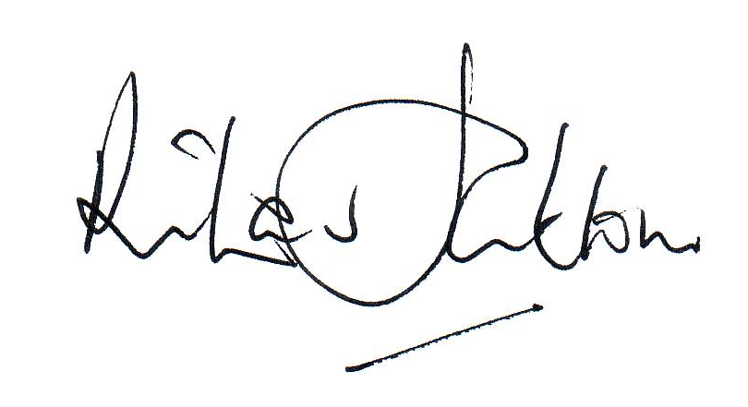  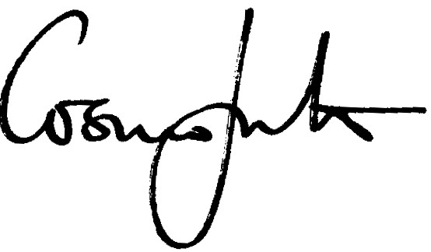
Date | 18th June 2024

Effective date of the policy | 1st September 2024
Circulation | Partners / all staff / parents / students on request  Published on the School's website and in the Student and Parent Handbook
Status | Complies with Part 7 of the Education (Independent Schools Standards) (England) Regulations 2014 and the National Minimum Standards for Boarding Schools 2022

